EXPERIMENT NO. 4

TITLE: Thread synchronization using counting semaphores and mutual exclusion using mutex.

AIM: To demonstrate an application with producer-consumer problem using counting semaphores and mutex

PRE REQUISITE: C, Support for Threads, POSIX mutex and semaphores

THEORY:
Producer/Consumer Problem :
General Situation:
- One or more producers are generating data and placing these in a buffer
- A single consumer is taking items out of the buffer one at time
- Only one producer or consumer may access the buffer at any one time
The Problem:
- Ensure that the Producer can’t add data into full buffer and consumer can’t remove data from empty buffer

Semaphores:
A semaphore is a counter used to provide access to shared data object for multiple processes. To obtain a shared resource a process needs to do following:
- Test the semaphore that controls the resource.
- If value of semaphore is positive the process can use the resource. The process decrements the semaphore value by one, indicating that it has used one until of the resource.
- If value is greater of semaphore is 0, the process goes to sleep until the semaphore value is greater than 0. When a process wakes up it returns to step 1.
Semaphores are counters for resources shared between threads. The basic operations on semaphores are: increment the counter atomically, and wait until the counter is non-null and decrement it atomically.
A common form of semaphore is called Binary semaphore. It controls a single resource and its value is initialized to 1.
The <semaphore.h> header shall define the sem_t type, used in performing semaphore operations.

1)int sem_init(sem_t *sem, int pshared, unsigned int value);
sem_init initializes the semaphore object pointed to by sem. The count associated with the semaphore is set initially to value. The pshared argument indicates whether the semaphore is local to the cur-rent process ( pshared is zero) or is to be shared between several processes ( pshared is not zero).

2)int sem_wait(sem_t * sem);
sem_wait suspends the calling thread until the semaphore pointed to by sem has non-zero count. It then atomically decreases the semaphore count.

3)int sem_trywait(sem_t * sem);
sem_trywait is a non-blocking variant of sem_wait. If the semaphore pointed to by sem has non-zero count, the count is atomically decreased and sem_trywait immediately returns 0.
4) int sem_post(sem_t * sem);
sem_post automically increases the count of the semaphore pointed to by sem. This function never blocks and can safely be used in asyn-chronous signal handlers.

5) int sem_getvalue(sem_t * sem, int * sval);
sem_getvalue stores in the location pointed to by sval the current count of the semaphore sem.

6)int sem_destroy(sem_t * sem);
sem_destroy destroys a semaphore object, freeing the resources it might hold.

Threads and Mutex

- Technically, a thread is defined as an independent stream of instructions that can be scheduled to run as such by the operating system. But what does this mean?
- To the software developer, the concept of a "procedure" that runs independently from its main program may best describe a thread.
- So, in summary, in thread:
  - Exists within a process and uses the process resources
  - Has its own independent flow of control as long as its parent process exists and the OS supports it
  - Duplicates only the essential resources it needs to be independently schedulable
  - May share the process resources with other threads that act equally independently (and dependently)
  - Dies if the parent process dies - or something similar
  - Is "lightweight" because most of the overhead has already been accomplished through the creation of its process.
Mutex
Mutex is an abbreviation for "mutual exclusion". Mutex variables are one of the primary means of implementing thread synchronization and for protecting shared data when multiple writes occur.
- A mutex variable acts like a "lock" protecting access to a shared data resource. The basic concept of a mutex as used in Pthreads is that only one thread can lock (or own) a mutex variable at any given time. Thus, even if several threads try to lock a mutex only one thread will be successful. No other thread can own that mutex until the owning thread unlocks that mutex. Threads must "take turns" accessing protected data.
- Mutexes can be used to prevent "race" conditions. An example of a race condition involving a bank transaction is shown below:
Creating and Destroying Mutexes
Routines:
pthread_mutex_init (mutex,attr)
pthread_mutex_destroy (mutex)
pthread_mutexattr_init (attr)
pthread_mutexattr_destroy (attr)
Usage:
- Mutex variables must be declared with type pthread_mutex_t, and must be initialized before they can be used. There are two ways to initialize a mutex variable:
  - Statically, when it is declared. For example:
pthread_mutex_t mymutex = PTHREAD_MUTEX_INITIALIZER;
  - Dynamically, with the pthread_mutex_init() routine. This method permits setting mutex object attributes, attr.
The mutex is initially unlocked.
- The attr object is used to establish properties for the mutex object, and must be of type pthread_mutexattr_t if used (may be specified as NULL to accept defaults). The Pthreads standard defines three optional mutex attributes:
  - Protocol: Specifies the protocol used to prevent priority inversions for a mutex.
  - Prioceiling: Specifies the priority ceiling of a mutex.
  - Process-shared: Specifies the process sharing of a mutex.
Note that not all implementations may provide the three optional mutex attributes.
- The pthread_mutexattr_init() and pthread_mutexattr_destroy() routines are used to create and destroy mutex attribute objects respectively.
- pthread_mutex_destroy() should be used to free a mutex object which is no longer needed.
Locking and Unlocking Mutexes
Routines:
pthread_mutex_lock (mutex)
pthread_mutex_trylock (mutex)
pthread_mutex_unlock (mutex)
Usage:
- The pthread_mutex_lock() routine is used by a thread to acquire a lock on the specified mutex variable. If the mutex is already locked by another thread, this call will block the calling thread until the mutex is unlocked.
- pthread_mutex_trylock() will attempt to lock a mutex. However, if the mutex is already locked, the routine will return immediately with a "busy" error code. This routine may be useful in preventing deadlock conditions, as in a priority-inversion situation.
- pthread_mutex_unlock() will unlock a mutex if called by the owning thread. Calling this routine is required after a thread has completed its use of protected data if other threads are to acquire the mutex for their work with the protected data. An error will be returned if:
  - If the mutex was already unlocked
  - If the mutex is owned by another thread
- There is nothing "magical" about mutexes...in fact they are akin to a "gentlemen's agreement" between participating threads. It is up to the code writer to insure that the necessary threads all make the the mutex lock and unlock calls correctly. The following scenario demonstrates a logical error:
- Thread 1 Thread 2 Thread 3
- Lock Lock
- A = 2 A = A+1 A = A*B
- Unlock Unlock

Program Mutual Exclusion and Synchronization of threads using POSIX Semaphores and/or
Mutex (producer-consumer problem)
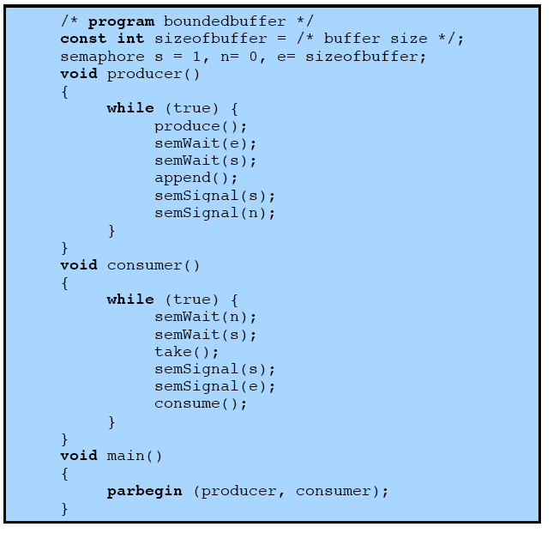

Figure:Bounded buffer producer con

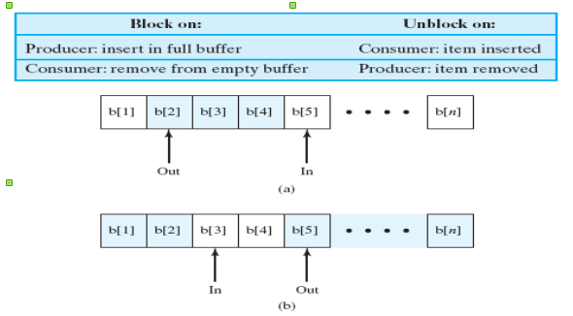
Figure: solution to bounded buffer producer-consumer using semaphore

INPUT:
- values to be inserted in and removed from the shared buffer
- Number of producers and consumers

OUTPUT:
- Synchronized update and access of above input

APPLICATION:
Wherever we have servers or applications, which can divide work among parallel tasks, can use threads. For synchronization of these threads while accessing and updating shared resources mutex and semaphores play important role.

CONCLUSION:

Thus we demonstrate that using mutex/semaphores we can synchronize access and update among competing threads.

FAQs:
1.What is a mutex and critical section?
2.List the requirements for mutual exclusion?
3.what is semaphore and what operations can be performed on a semaphore?
4. what is the difference between binary and general semaphore?
5. what is the difference between strong and weak semaphore?
6. what is the producer consumer problem?Explain bounded buffer producer consumer problem as well as infinite buffer producer consumer.
7. Explain POSIX semaphores?
8. Explain pthread_mutex_t.
9. Explain pthread_mutex_lock() and pthread_mutex_unlock() functions with reference to c.
10.Explain sem_t, sem_wait(), sem_post() with reference to c.
11.Explain sem_init() function with its parameters in detail.
12. Explain pthread_create() and pthread_join() function in detail.
#include <pthread.h>
#include <semaphore.h>
#include <stdlib.h>
#include <stdio.h>

#define MaxItems 5 // Maximum items a producer can produce or a consumer can consume
#define BufferSize 5 // Size of the buffer

sem_t empty;
sem_t full;
int in = 0;
int out = 0;
int buffer[BufferSize];
pthread_mutex_t mutex;

void *producer(void *pno)
{
int item;
for(int i = 0; i < MaxItems; i++) {
item = 5; // Produce an random item
sem_wait(&empty);
pthread_mutex_lock(&mutex);
buffer[in] = item;
printf("Producer %d: Insert Item %d at %d\n", *((int *)pno),buffer[in],in);
in = (in+1)%BufferSize;
pthread_mutex_unlock(&mutex);
sem_post(&full);
}
}
void *consumer(void *cno)
{
for(int i = 0; i < MaxItems; i++) {
sem_wait(&full);
pthread_mutex_lock(&mutex);
int item = buffer[out];
printf("Consumer %d: Remove Item %d from %d\n",*((int *)cno),item, out);
out = (out+1)%BufferSize;
pthread_mutex_unlock(&mutex);
sem_post(&empty);
}
}

int main()
{
pthread_t pro[5],con[5];
pthread_mutex_init(&mutex, NULL);
sem_init(&empty,0,BufferSize);
sem_init(&full,0,0);

int a[5] = {1,2,3,4,5}; //Just used for numbering the producer and consumer

for(int i = 0; i < 5; i++) {
pthread_create(&pro[i], NULL, (void *)producer, (void *)&a[i]);
}
for(int i = 0; i < 5; i++) {
pthread_create(&con[i], NULL, (void *)consumer, (void *)&a[i]);
}

for(int i = 0; i < 5; i++) {
pthread_join(pro[i], NULL);
}
for(int i = 0; i < 5; i++) {
pthread_join(con[i], NULL);
}

pthread_mutex_destroy(&mutex);
sem_destroy(&empty);
sem_destroy(&full);
return 0;
}

